|  |  |  |
| --- | --- | --- |
| **Reliabilty Event Abridged Learning (REAL)** | **All Shell Assets** | **April 2021** |

Soku Gas Plant OSD1 from Power Outage

**Target audience for this alert**

* Production Asset/MRTA/Engineering

**Relevant AMS Processes**

Manage Threats and Opportunities, Manage Equipment Care, Ensure Safe Production, Perform Turnaround, Learning

**What happened**

Soku Gas Plant experienced OSD1 due to power outage at 0415hrs on 18th April 2021 when the duty gas generator G-8101 tripped on HiHi Turbine Air Inlet Filter DP.

**Why it happened**

* G-8101 was the only available generator out of the 3 GTGs (G-8111, G-8121)
  + G-8111 was manually shut down, being almost due for statutory 30k hours inspection (engine change out)
  + G-8121 was down on alternator cooler vent fan failure
* Filter became clogged from accumulated dust

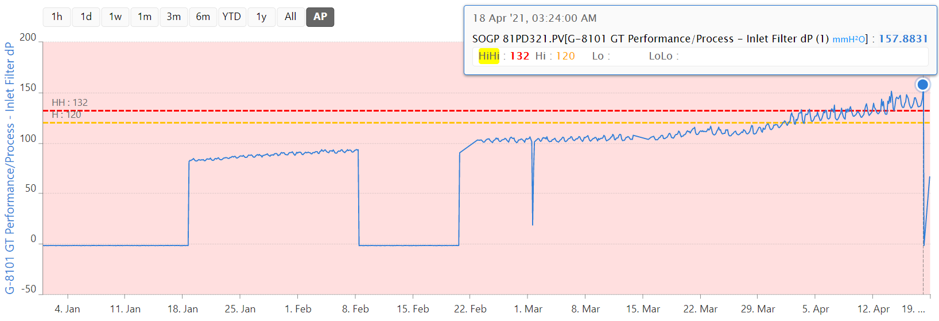

* Filter change out was deferred to an approaching shutdown period
* TAM was postponed from March 2021 to April 2021 (kick off at 19th April 2021) to align with NLNG.

**Consequences**

* Expected: Soku Gas Plant produces 285MMscfd of gas and 16kbpd condensate until planned shutdown on 19th April 2021
* Actual: Soku GP experienced an OSD1 trip at 0415hrs on 18th April 2021
* Impact: 1.16kbbl of oil and 20MMscf of gas deferred.

**Lessons learned**

* Though downtime can be minimised by deferring certain activities to TAM period, the reverse might occur if the schedule changes.
* Escalate critical CM activity to site leadership and secure shutdown approval to execute task

**Actions**

* Replace filters and restart generator to restore power
* Restore G-8121 to improve power generator redundancy
* Carry out engine change out for G-8111 to improve power generator redundancy

**Recommendation**

* Provide instruction to carry out risk assessment and reevaluate mitigation for activities that were deferred to the shutdown window. When there is a change in TAM schedule,

**Review By:**

1. Uranta, Noble
2. Etire, Azibanato
3. Piate, Chris
4. Onabajo, Abiodun